PES UNIVERSITY

UE19CS352

Cloud Computing

Assignment - 05

Introduction to AWS Key Management Service(KMS)

Name : Suhan B Revankar

SRN : PES2UG19CS412

Section : G Section

The following screenshots are to be submitted:

1a.png: Showing KMS key created. The name of the alias should be: <Your SRN> Eg: pes1201900001.

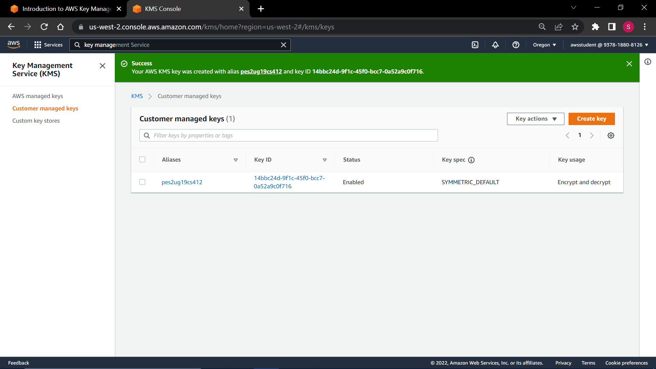

2a.png: Showing the configured CloudTrail named <Your SRN>-trail.

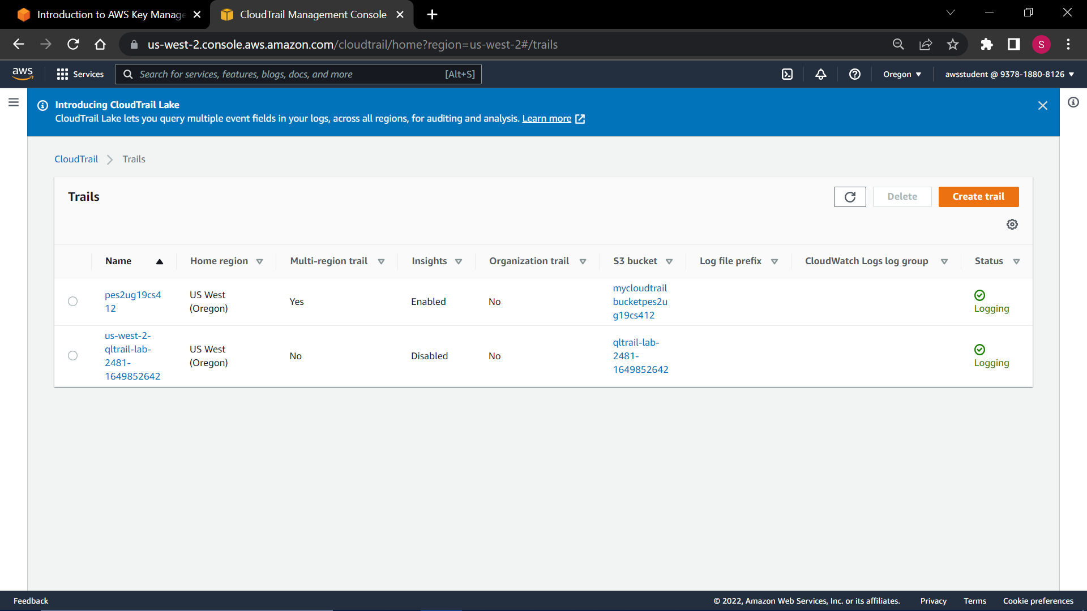

3a.png: Showing the configured bucket named mycloudtrailbucketXXXX. where XXXX are the last 4 digits of your SRN. You can pad it with 0s if you have less than 4 digits.

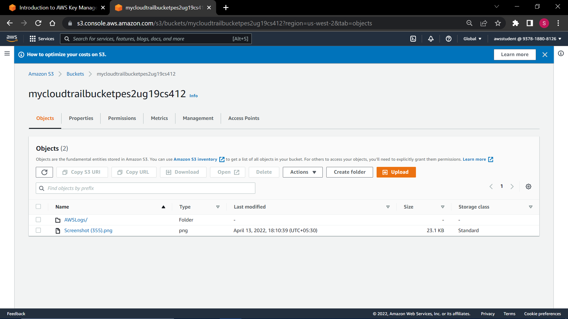

4a.png: Showing the “Access Denied” page when you open the link to the image stored in the bucket.

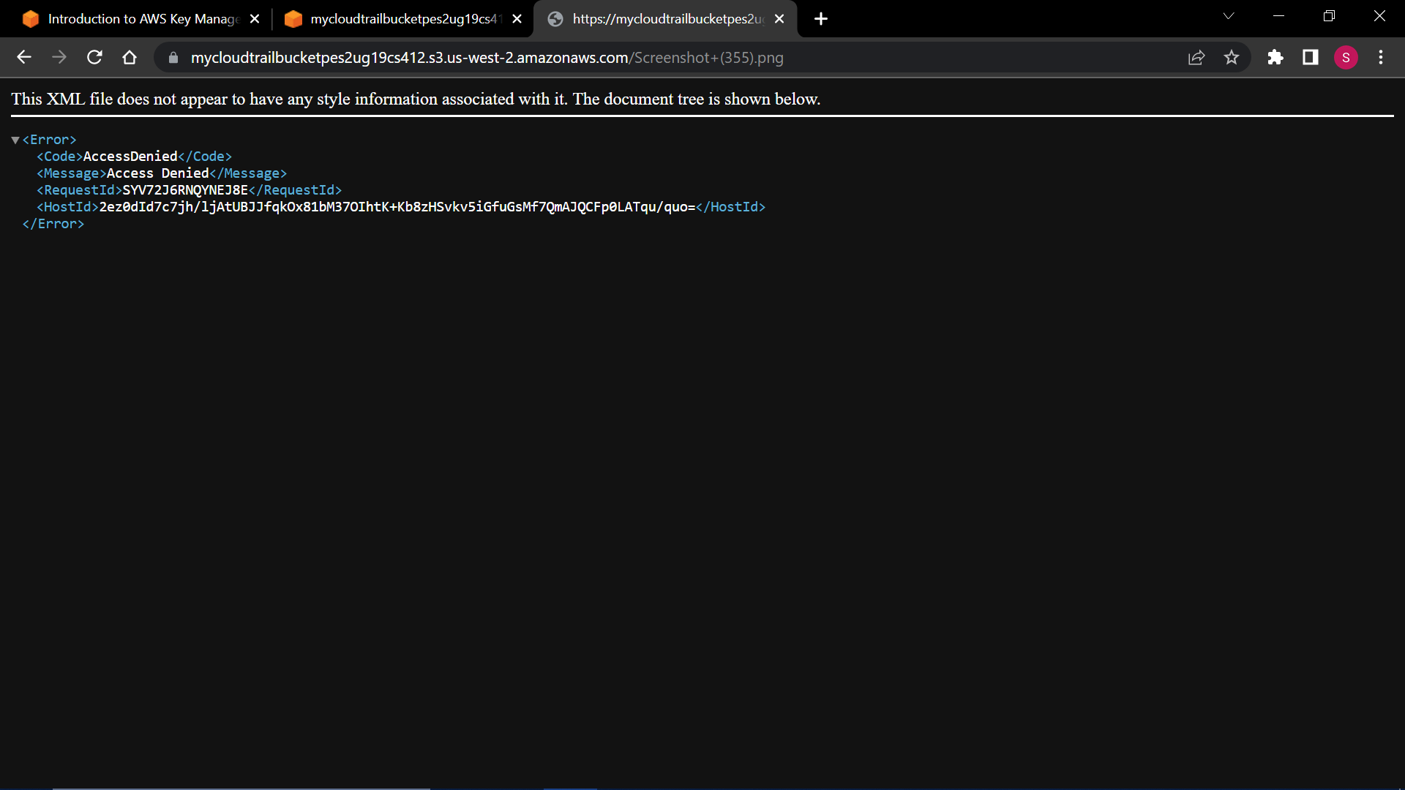

4b.png: Showing the “Requests specifying Server Side Encryption with AWS KMS managed keys require AWS Signature Version 4” page when you open the link to the image stored in the bucket.

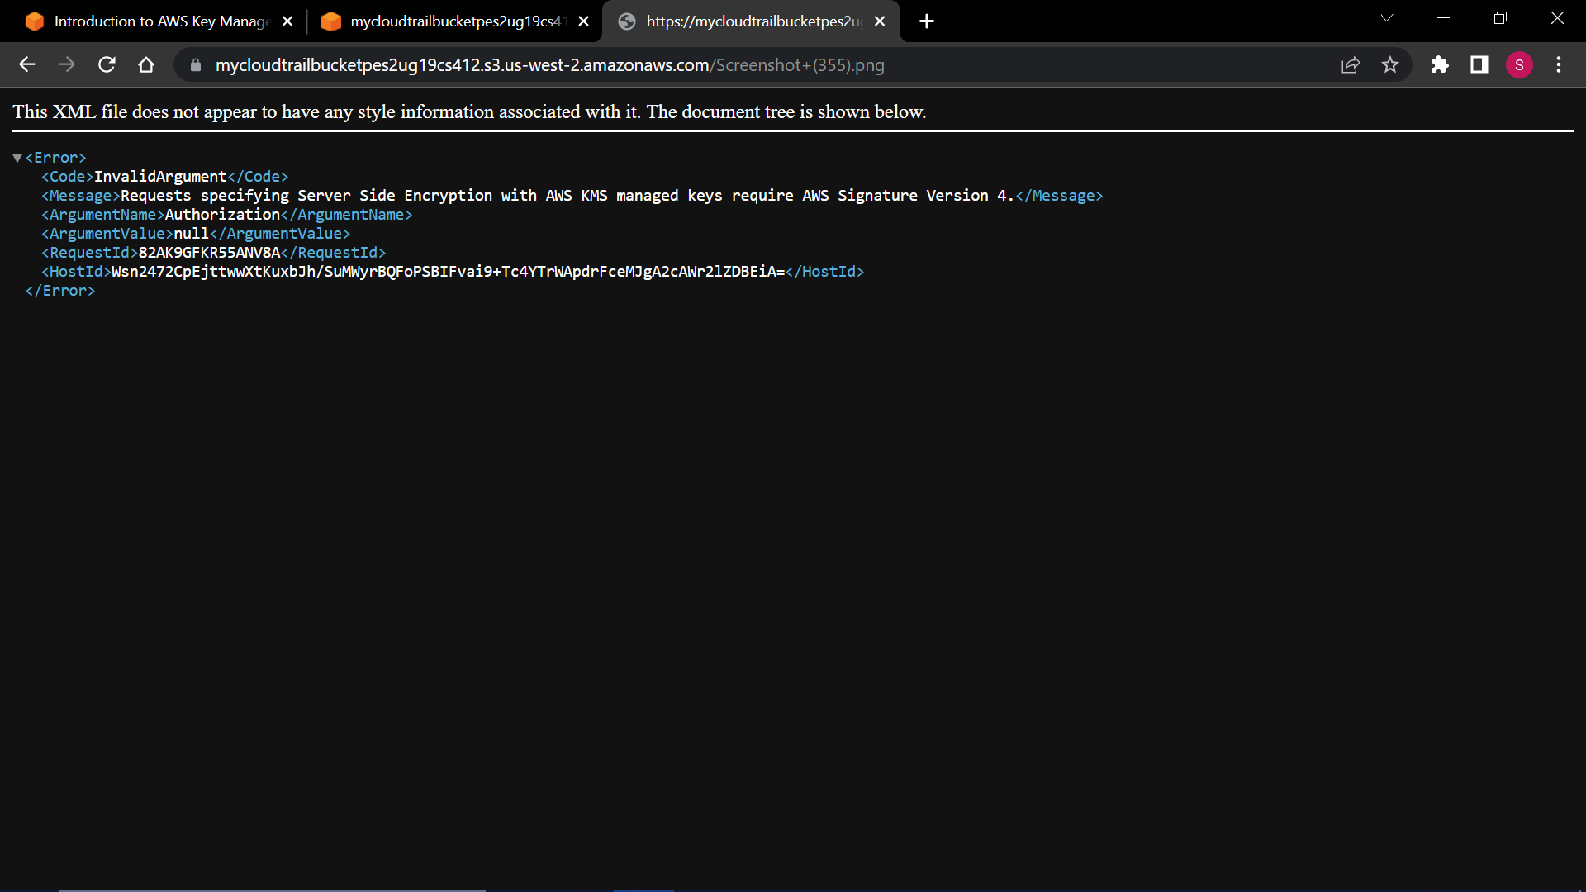

5a.png: Showing the key-id being present in the json we get from .gzip’ed cloud trail logs.

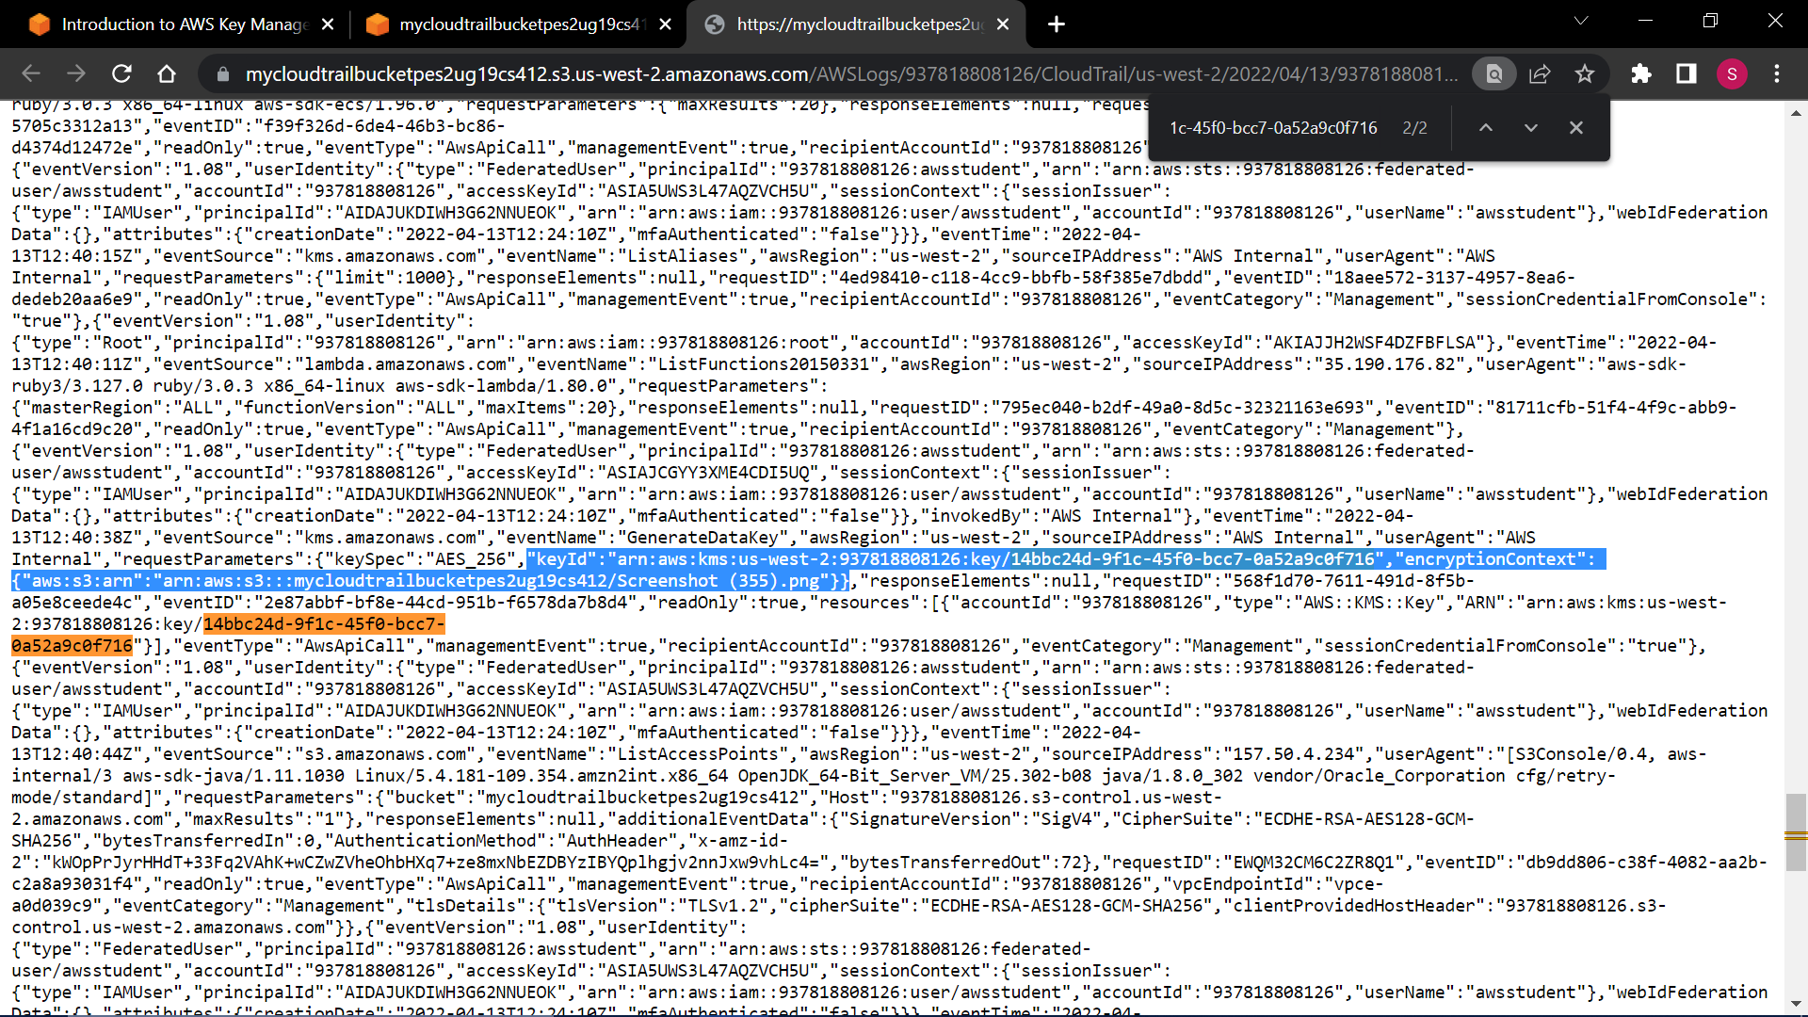

6a.png: Showing the state of key users after the user has been removed.

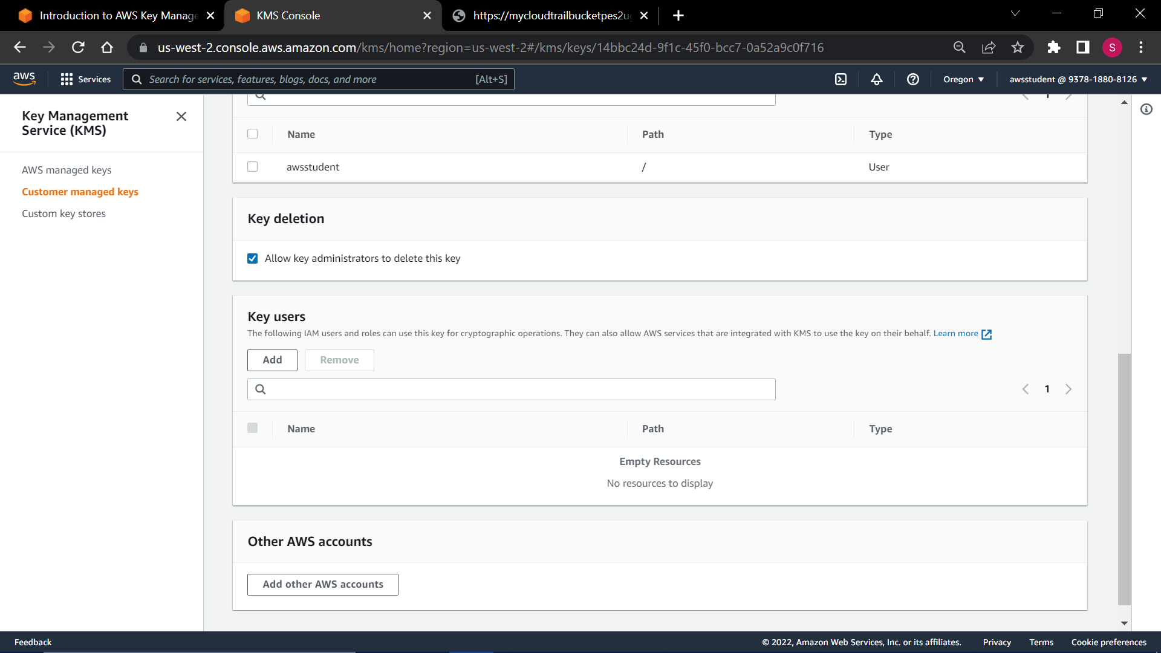

6b.png: Showing the state of key users after the user has been added.



